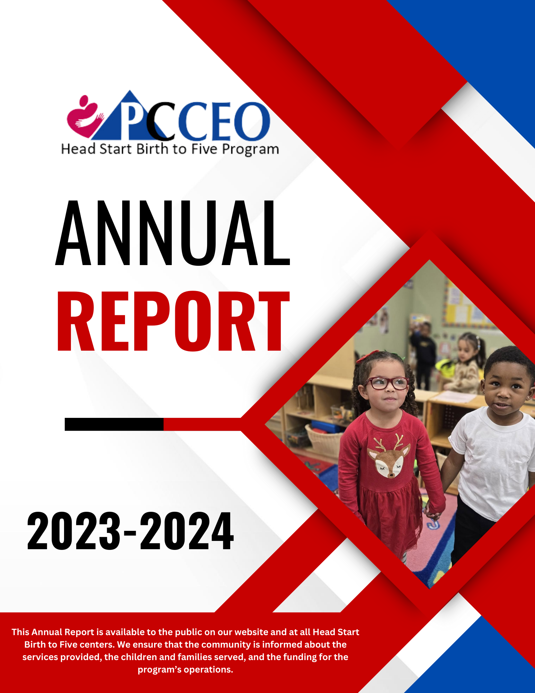

# 

Contents

**PROGRAM PERFORMANCE AND SERVICE DELIVERY STATISTICS 3**

**INDEPENDENT AUDITORS' REPORT 3**

**Promoting Services for Expectant Moms, Families, and Children Birth through 5 6**

**Change in Scope 6**

**Head Start Birth-to-Five Enrollment: 7**

**Developmental Screening and Individualized Learning in PCCEO Birth to Five Program 7**

**Integration of the Birth to Five Early Learning Outcomes Framework 9**

**Head Start Supports Families 10**

**Transportation Services 11**

**HEAD START/ EARLY HEAD START OPERATIONG BUDGET 2023-2024 12**

# PROGRAM PERFORMANCE AND SERVICE DELIVERY STATISTICS

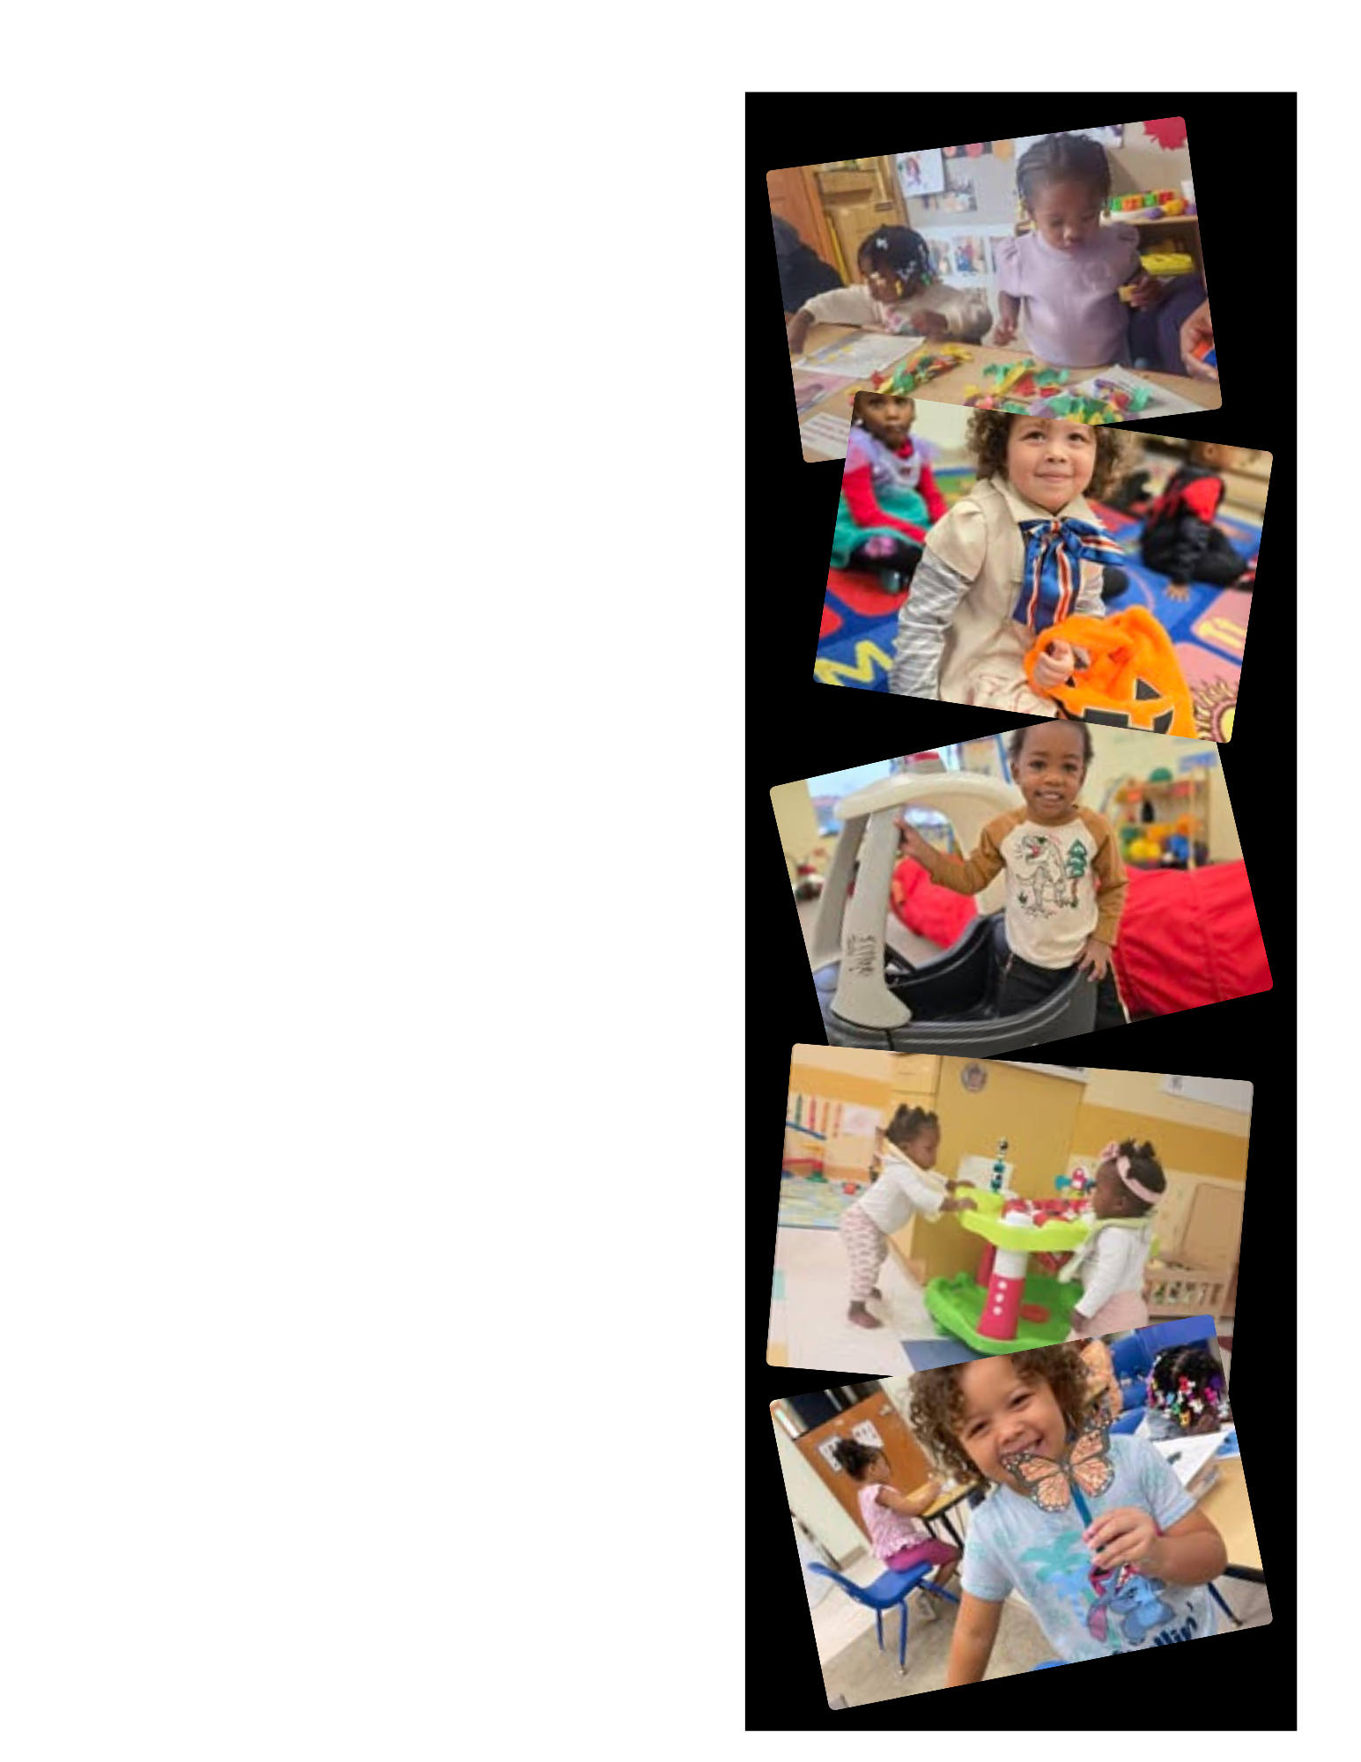

**Number of Children Served**

* **Head Start:** 410
* **Early Head Start:** 115
* **Total:** 525

**Funded Enrollment**

* **Head Start:** 585
* **Early Head Start:** 111
* **Total:** 696

**The Average Monthly Enrollment**

* **Head Start:** 56.11%
* **Early Head Start:** 54.26%

**Percent of Eligible Children Served by HS/EHS**

* **Head Start:** 46%
* **Early Head Start:** 7.4%

**Number of Children Who Received a Medical Exam**

* **Head Start:** 100%
* **Early Head Start:** 100%

**Number of Children Who Received a Dental Exam**

* **Head Start:** 100%
* **Early Head Start:** 79%

**Number of Children with Disabilities**

* **Head Start:** 12%
* **Early Head Start:** .87%

**Percentage of Children Who Are Dual Language**

**Learners**

* **Head Start:** 10.24%
* **Early Head Start:** 21.74%

**Number of Children with an Individualized**

**Education Plan - (IEP), Individualized Family**

**Service Plan** (**IFSP)**

* **Head Start:** 22
* **Early Head Start:** 0

**Number of Children/Families Receiving Mental**

**Health Referrals**

* **Head Start:** 18
* **Early Head Start:** 20

**Percentage of Children Receiving Vision/Hearing**

**Screenings**

* **Head Start:** 100%
* **Early Head Start/PI:** 28%

# 

# INDEPENDENT AUDITORS' REPORT

**Report on the Consolidated Financial Statements**

We have audited the accompanying consolidated financial statements of Peoria Citizens Committee for Economic Opportunity, Inc., (a nonprofit organization) and subsidiaries, which comprise the consolidated statement of financial position as of December 31, 2022 and the related consolidated statements of activities & other comprehensive income, functional expenses, and cash flows for the year then ended, and the related notes to the consolidated financial statements. The prior year summarized comparative information has been derived from Peoria Citizens Committee for Economic Opportunity, Inc.'s December 31, 2022, financial statements, and in our report dated September 22, 2022 we expressed an unqualified opinion on those financial statements.

**Management's Responsibility for the Consolidated Financial Statements**

Management is responsible for the preparation and fair presentation of these consolidated financial statements in accordance with accounting principles generally accepted in the United States of America; this includes the design, implementation, and maintenance of internal control relevant to the preparation and fair presentation of financial statements that are free from material misstatement, whether due to fraud or error.

**Auditors' Responsibility**

Our responsibility is to express an opinion on these consolidated financial statements based on our audit. These consolidated financial statements also include the financial activity of four (4) other subsidiaries, Peoria Housing Resources, LLC and Peoria Affordable Housing Initiative, in which the two entities have equity ownership in Okpara, LP and Okpara II. The financial statements of Peoria Housing Resources, LLC and Peoria Affordable Housing Initiative reflect an unaudited balance of $22,277 in total assets as of December 31, 2022 and an unaudited balance of $25,257 in total support and revenues. These amounts were immaterial to the consolidated financial statements taken as a whole. We conducted our audit in accordance with auditing standards generally accepted in the United States of America and the standards applicable to financial audits contained in *Government Auditing Standards,* issued by the Comptroller General of the United States. Those standards require that we plan and perform the audit to obtain reasonable assurance about whether the consolidated financial statements are free of material misstatement.

An audit involves performing procedures to obtain audit evidence about the amounts and disclosures in the consolidated financial statements. The procedures selected depend on the auditors' judgment, including the assessment of the risks of material misstatement of the consolidated financial statements, whether due to fraud or error. In making those risk assessments, the auditors consider internal control relevant to the entity's preparation and fair presentation of the consolidated financial statements in order to design audit procedures that are appropriate in the circumstances, but not for the purpose of expressing an opinion on the effectiveness of the entity's internal control. Accordingly, we express no such opinion. An audit also includes evaluating the appropriateness of accounting policies used and the reasonableness of significant accounting estimates made by management, as well as evaluating the overall presentation of the consolidated financial statements.

We believe that the audit evidence we have obtained is sufficient and appropriate to provide a basis for our audit opinion.

**Opinion**

In our opinion, based on our audit and the report of the other auditors, the consolidated financial statements referred to above present fairly, in all material respects, the financial position of Peoria Citizens Committee for Economic Opportunity, Inc. and subsidiaries as of December 31, 2022, and the

changes in its net assets and its cash flows for the year then ended in accordance with accounting principles generally accepted in the United States of America.

**Report on Summarized Comparative Information**

We have previously audited the Peoria Citizens Committee for Economic Opportunity, Inc.'s December 31, 2022 financial statements and, and we expressed an unmodified audit opinion on those financial statements in our report dated September 22, 2022. In our opinion, the summarized comparative information presented herein as of and for the year ended December 31, 2022 is consistent in all material respects with the audited financial statements from which it has been derived.

**Other Matters**

*Other Information*

Our audit was conducted for the purpose of forming an opinion on the consolidated financial statements as a whole. The accompanying Schedules of Activities - Illinois Department of Commerce & Economic Opportunity, Okpara, **LP,** Peoria Housing Resources, **LLC,** Peoria Affordable Housing Initiative, Revolving Loan Program, Management and General Fund, In-Kind Contributions, and the Financial Status Report of the Department of Health and Human Services - Head Start are presented for purposes of additional analysis and are not a required part of the basic financial statements. The accompanying Schedule of Expenditures of Federal Awards, as required by Title 2 U.S. Code of Federal Regulations Part *200, Uniform Administrative Requirements, Cost Principles, and Audit Requirements for Federal Awards,* is presented for purposes of additional analysis and is not a required part of the financial statements. Such information is the responsibility of management and was derived from and relates directly to the underlying accounting and other records used to prepare the consolidated financial statements. The information has been subjected to the auditing procedures applied in the audit of the consolidated financial statements and certain additional procedures, including comparing and reconciling such information directly to the underlying accounting and other records used to prepare the consolidated financial statements or to the consolidated financial statements themselves, and other additional procedures in accordance with auditing standards generally accepted in the United States of America. In our opinion, the information is fairly stated, in all material respects, in relation to the financial statements as a whole.

**Other Reporting Required by Government Auditing Standards**

In accordance with *Government Auditing Standards,* we have also issued our report dated November 04, 2022 on our consideration of Peoria Citizens Committee for Economic Opportunity, Inc.'s internal control over financial reporting and on our tests of its compliance with certain provisions of laws, regulations, contracts, and grant agreements and other matters. The purpose of that report is to describe the scope of our testing of internal control over financial reporting and compliance and the results of that testing, and not to provide an opinion on internal control over financial reporting or on compliance. That report is an integral part of an audit performed in accordance with *Government Auditing Standards* in considering Peoria Citizens Committee for Economic Opportunity, Inc.'s internal control over financial reporting and compliance.

**Ragland, Arnold, Buchanan, Morris & Associates, LLC Certified Public Accountants**

Mokena, Illinois – November 04, 2022

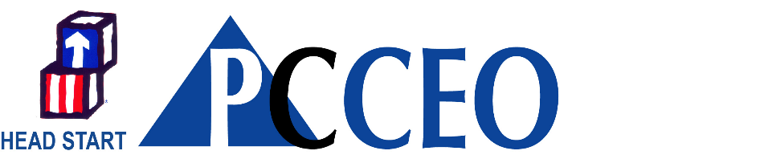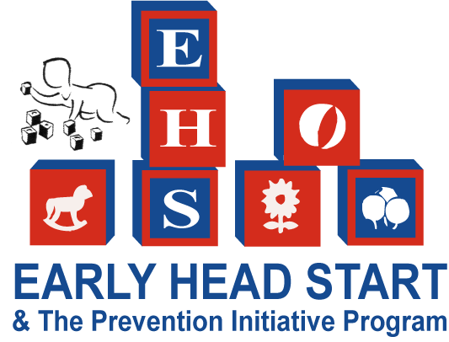

# Promoting Services for Expectant Moms, Families, and Children Birth through 5

Peoria Citizen’s Committee for Economic Opportunity, Inc. (PCCEO) 's Birth to 5 Head Start Program is committed to providing high-quality, comprehensive services to the children, families, and Expectant women served. PCCEO's Head Start program offers excellent early learning and child health services to families living in high-risk environments. To ensure that these services are highly effective, the program also provides family and community engagement services to help families provide quality early learning experiences for their children, strengthen family bonds, and address any needs they may have.

# Change in Scope

PCCEO Birth to Five Program submitted a reduction granted a Change of Scope. This allowed the program to reduce the number of slots for three to five-year-old slots and the birth to 3. Birth to 3 slots were reduced from 585 slots to 392 slots. Slots for children aged birth to 3 and Expectant moms were reduced from 111 slots to 98. Reducing slots allowed the program to be competitive in recruiting and retaining staff. Additionally, Home-based slots were reduced from 97 families to 30 families. Center-based slots for birth to 3-aged children grew from 21 to 53 slots. The chart below shows the changes implemented due to the Change in Scope.

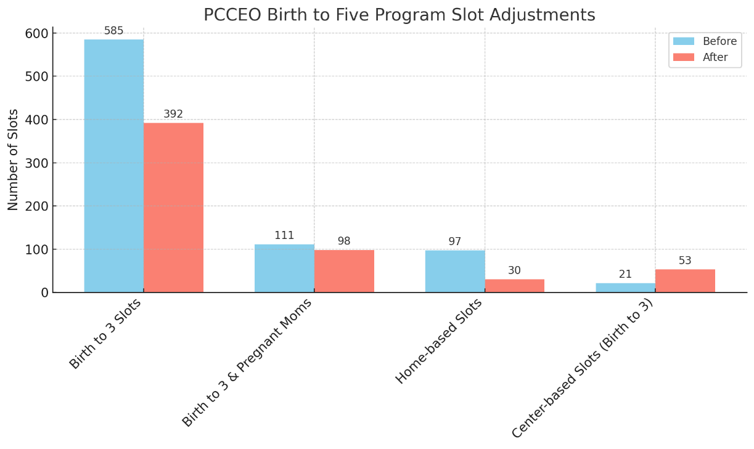

**The change in scope has produced the desired results. Head Start is not only fully enrolled but also fully staffed.**

# Head Start Birth-to-Five Enrollment:

| **Center/Program** | **Age Range** | **Enrollment** | **Status** |
| --- | --- | --- | --- |
| Annie Jo Gordon | 3–5 | 80 | Fully Enrolled |
| CityLink | Birth–5 | 71 | Fully Enrolled |
| Manual | 3–5 | 40 | Fully Enrolled |
| Pierson | Birth–3 | 8 | Fully Enrolled |
| Sheridan | Birth–5 | 67 | Fully Enrolled |
| Webster | Birth–5 | 113 | Fully Enrolled |
| Woodruff | 3–5 | 60 | Fully Enrolled |
| Home-based | 3-5 | 38 | Fully Enrolled |
| Expectant Moms | N/A | 15 | Fully Enrolled |

# Developmental Screening and Individualized Learning in PCCEO Birth to Five Program

**Screening and Assessment**

* **Timeline**: All newly enrolled children are screened within 45 days of enrollment.
* **Purpose**: To help staff individualize learning experiences that promote early learning outcomes.
* **Tools Used**:
  + Brigance – Social and Emotional Screening
  + Learning Accomplishment Profile Assessment (LAP 3) (ages 3 to 5)
  + Early Learning Accomplishment Profile Assessment (ELAP – ages birth to 3)

**Process**:

* Home Visitors and Education staff conduct the screenings and ongoing assessments.
* Data from these screenings identify children who may require further evaluation.
* Every child is given an **individualized lesson plan**, regardless of program option.

**Curriculum**

The **Creative Curriculum** is a research-based curriculum designed to foster the whole child's development through intentional, play-based learning. PCCEO Birth – Five programs support the use of Creative Curriculum because of developmentally appropriate content focusing on a:

**1. Comprehensive Framework**

* **Whole-Child Development**: It supports cognitive, physical, social-emotional, and language development.
* **Focus on Key Areas**: The curriculum integrates literacy, math, science, social studies, and the arts within a structured, developmentally appropriate framework.

**2. Play-Based and Hands-On Learning**

* Activities encourage active exploration and problem-solving, making learning enjoyable and meaningful.
* Children learn through investigations, projects, and creative activities that align with their interests and developmental needs.

**3. Individualized and Inclusive**

* It emphasizes **individualized teaching** to meet the needs of diverse learners, including dual-language learners and children with disabilities.
* Teachers are encouraged to adapt strategies for each child's strengths, needs, and cultural background.

**4. Promotes Social-Emotional Development**

* Social-emotional learning (SEL) is integrated into daily routines and activities to help children develop self-regulation, cooperation, and conflict resolution skills.
* Encourages a positive classroom community.

**5. Alignment with Standards**

* The Creative Curriculum aligns with Illinois State Early Learning Standards and the Head Start Early Learning Outcomes Framework.
* Ensures children are prepared for kindergarten and beyond.

**6. Guidance for Teachers**

* Provides detailed lesson plans and resources.
* Offers professional development opportunities to help educators implement the curriculum effectively.

**7. Family Engagement**

* Includes tools and activities to involve families in their children’s learning, fostering strong school-home connections.
* Encourages communication and shared learning experiences between teachers and families.

**8. Encourages Curiosity and Critical Thinking**

* Investigative studies build on children's natural curiosity and deepen their understanding of concepts.
* Develop problem-solving and inquiry skills through exploration and questioning.
* **Baby Talk** is the Curriculum used for Home-based families.
  1. Facilitates family-child interaction
  2. Affirms child capabilities and competence in families
  3. Promotes actively listening, reflecting, and using strength-based strategies
  4. Promotes community systems building to provide trustworthy relationships for families.
  5. Trauma-informed, culturally sensitive practice
  6. Uses infant mental health approach
  7. Flexibility to meet individual family, parent/caregiver, and child priorities
  8. Engages families in support of optimal early childhood development
  9. Applies a developmental approach to family engagement

The curriculum is supplemented with Conscious Discipline, a comprehensive social and emotional intelligence management program.

# Integration of the Birth to Five Early Learning Outcomes Framework

The **Birth to Five Early Learning Outcomes Framework** is a foundation for guiding curriculum choices, selecting learning materials, and planning daily activities. It supports intentional teaching practices and encourages family engagement in children’s learning.

**Family Engagement and Teaching Practices Include**:

* **Parent-Teacher Conferences**: Providing regular opportunities to discuss children’s progress.
* **Developmental Screenings**: Conducted to identify developmental needs and inform individualized planning.
* **Ongoing Assessments**: These are used to monitor and adjust learning strategies based on each child’s progress.
* **Home Visits**: Strengthening family connections and aligning learning activities with the home environment.
* **Children’s Daily Experiences**: Structured to support developmental milestones and learning goals.
* **Individualized Lesson Plans**: Tailored to meet each child's unique needs and strengths.
* **Parental Input**: Actively incorporated into the planning and teaching process to ensure holistic support.

This framework ensures a comprehensive, child-centered approach that bridges classroom learning and family involvement.

**School Readiness Preparing Children for Kindergarten**

Preparation for Kindergarten begins at birth. Parents and staff's experiences in Head Start t lay the foundation for more formal education in primary school. Careful monitoring of children’s development ensures that their learning needs are addressed and that every effort is made to help them become successful not only in kindergarten but also in life.

Children transitioning from Early Head Start to Head Start begins when children are 2.5 years of age. Family Development Specialists (FDS) assist families in completing transition packets. Before enrollment, the children and families have an orientation opportunity to visit the child’s Head Start classroom.

PCCEO Head Start transition efforts are designed to help ease the entry from Early Head Start to Head Start and from Head Start into kindergarten. PCCEO partners with the local school districts regarding the many opportunities to support children transitioning to kindergarten; kindergarten registration day, participation on the kindergarten registration committee, Early Childhood Forum, and the Head Start annual Transition Fair.

PCCEO Head Start Birth to Five program has adopted a plan of school readiness for all children transitioning to kindergarten that aligns with the goals and expectations of the following:

* Head Start Early Learning Outcomes Framework
* State Early Learning Standards
* Expectations and requirements of the local school system
  + Supports individual differences
  + Assesses children’s progress on an ongoing basis
  + Includes strategies for achieving these goals
  + Allows parents to provide input on readiness goals that they believe are important as their child transitions to preschool and kindergarten.

**Head Start Supports Families**

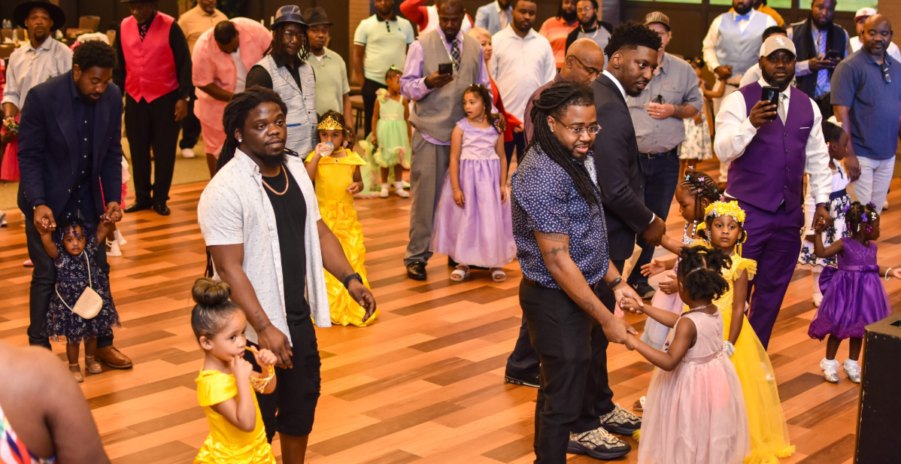

Head Start supports families in multiple ways by providing comprehensive services that go beyond early childhood education. These services are designed to address the needs of children and their families, fostering long-term success for both. Here are specific ways Head Start supports families:

**1. Educational Support**

* **Child-Focused Programs:** Offers high-quality early childhood education tailored to prepare children for kindergarten and beyond.
* **Parental Engagement:** Encourages active parental involvement in their child’s education through workshops, classroom participation, and regular parent-teacher meetings.
* **Family Literacy:** Provides resources to improve literacy skills for both parents and children.

**2. Health and Nutrition Services**

* **Health Screenings:** Conduct regular health, dental, and vision screenings for children to ensure they are healthy and ready to learn.
* **Immunizations:** Assists families in accessing vaccinations and preventive care.
* **Nutritious Meals:** Provides healthy meals and snacks that meet federal nutrition guidelines.
* **Mental Health Services:** Connects families with counseling and mental health resources when needed.

**3. Family Development**

* **Goal Setting:** Helps families set and achieve goals through family partnership agreements.
* **Parenting Workshops:** Offers parenting classes to enhance parenting skills and support child development.
* **Home Visits:** Provides home-based education and support to guide parents in creating an enriching learning environment at home.

**4. Economic Support**

* **Job Training:** Offers or partners with programs that provide job training and employment resources for parents.
* **Financial Literacy:** Conducts workshops on budgeting, saving, and managing finances.
* **Access to Benefits:** Assists families in navigating resources like housing assistance, SNAP, or childcare subsidies.

**5. Social and Emotional Support**

* **Community Building:** Connects families through events like parent meetings, family nights, and community celebrations.
* **Social Networks:** Helps families build support networks by linking them with local organizations and services.
* **Support During Challenges:** Provides crisis intervention services to families facing emergencies, such as homelessness or domestic issues.

**6. Tailored Services for Expectant Moms**

* **Prenatal Support:** Offers prenatal care information and health education for Expectant mothers.
* **Parental Education:** Prepares parents for the arrival of their baby and supports healthy development during the first years of life.

**7. Advocacy and Empowerment**

* **Empowering Families:** Encourages families to take leadership roles in the program, such as serving on Policy Councils or committees.
* **Cultural Competence:** Recognizes and incorporates families’ cultural backgrounds into the learning environment.
* **Advocacy Skills:** Teaches families how to advocate for their child’s education and well-being.

Head Start takes a holistic approach, recognizing that family well-being is integral to a child's success. By providing these comprehensive supports, Head Start ensures families have the tools and resources needed to thrive.

Head Start measures success through child-focused outcomes, family progress, program quality assessments, and community impact. The program employs evidence-based tools and strategies to evaluate how well it supports children and families. Here's an overview of how Head Start gauges its success:

# Transportation Services

Transportation services are limited to serving families living in homeless shelters for the 3—to 5-age group.

**HEAD START/ EARLY HEAD START OPERATIONG BUDGET 2023-2024**

|  |  |  |  |  |  |  |  |  |  |
| --- | --- | --- | --- | --- | --- | --- | --- | --- | --- |
| **HEAD START/EARLY HEAD START OPERATING BUDGET 2023 - 2024** | | | | | | | | | |
|  |  |  |  |  |  |  |  |  |  |
|  |  |  |  |  |  |  |  |  |  |
|  | PA 22 |  | PA 20 | **Total** |  | PA 25 |  | PA 21 | **Total** |
| **Salaries** | 3,186,761 | 0 | - | **3,186,751** |  | 725,521 |  | - | **726,280** |
|  |  |  |  |  |  |  |  |  |  |
| **Fringe Benefits** | 1,074,156 |  | - | **1,074,156** |  | 273,224 |  | - | **266,202** |
|  |  |  |  |  |  |  |  |  |  |
| **Travel** | 11,553 | - | 9,000 | **20,553** |  | 2,000 |  | 2,000 | **9,314** |
|  |  |  |  |  |  |  |  |  |  |
| **Equipment** | 0 | - | - | **0** |  | 0 | 0 | - | **13,166** |
|  |  |  |  |  |  |  |  |  |  |
| **Supplies** | 121,171 |  | - | **121,171** |  | 17,477 |  | 2,510 | **47,350** |
|  |  |  |  |  |  |  |  |  |  |
| **Contract Services** | 277,544 | - | 11,500 | **289,044** |  | 30,434 |  | 5,125 | **39,146** |
|  |  |  |  |  |  |  |  |  |  |
| **Other Costs** | 733,292 |  | 38,111 | **771,603** |  | 235,336 |  | 19,758 | **355,539** |
|  |  |  |  |  |  |  |  |  |  |
|  |  |  |  |  |  |  |  |  |  |
| Total | **5,404,477** |  | **58,811** | **5,463,288** |  | **1,283,992** |  | **29,393** | **1,313,385** |
|  |  |  |  |  |  |  |  |  |  |
| Indirect Charges | **531,165** |  |  | **531,165** |  | **117,103** |  |  | **117,103** |
|  |  |  |  |  |  |  |  |  |  |
|  |  |  |  |  |  |  |  |  |  |
| **Grant Award** | 5,935,642 |  | 58,811 | 5,994,463 |  | 1,401,095 |  | 29,393 | 1,430,488 |

|  |  |  |  |  |  |  |  |  |  |  |
| --- | --- | --- | --- | --- | --- | --- | --- | --- | --- | --- |
| **HEAD START/EARLY HEAD START**  **BUDGET 2022 - 2023** | | | | **Total** | **2220** | **2220C** | **2020** | **2520** | **2520C** | **2120** |
|  |  |  |  |  |  |  |  |  |  |  |
| **Federal Share of**  **Total Budget** | |  | 7,851,290 |  | 7,851,290 | 5,806,610 | 0 | 58,811.00 | 1,344,826 | 0 | 29,393 |
|  |  |  |  |  |  |  |  |  |  |  |
| **Third Party**  **Contributions (In-kind)** |  | 1,727,583 |  |  |  |  |  |  |  |  |
|  |  |  |  |  |  |  |  |  |  |  |
| **TOTAL**  **BUDGETS** |  | **9,578,873** |  |  |  |  |  |  |  |  |
|  |  |  |  |  |  |  |  |  |  |  |
|  |  |  |  |  |  |  |  |  |  |  |
| **HEAD START/EARLY HEAD START EXPENDITURES 2022 - 2023** | | | |  | FED |  | PROG INC | INK |  |  |
|  |  |  |  | - |  |  |  |  |  |  |
| **Head Start Training & Technical Assistance**  **(PA20)** |  | 48,216.73 |  | 48,216.73 | 48,216.73 |  |  |  |  |  |
|  |  |  |  | - |  |  |  |  |  |  |
| **Head Start Part- Day (PA22) + In-**  **kind + Project** |  | 6,028,893.60 |  | 6,028,893.60 | 5,219,384.48 | 0 | 30,028.13 | 779,480.99 |  |  |
|  |  |  |  |  |  |  |  |  |  |  |
| **Head Start CARES** |  | 458,663.99 |  | 458,663 | 458,663 |  |  |  |  |  |
|  |  |  |  | - |  |  |  |  |  |  |
| **Early Head Start Training & Technical**  **Assistance (PA21)** |  | 11,929.75 |  | 11,929.75 | 11,929.75 |  |  |  |  |  |
|  |  |  |  | - |  |  |  |  |  |  |
| **Early Head Start (PA25) + In-kind**  **+ Project** |  | 1,636,721.31 |  | 1,636,721.31 | 1,272,379.30 | 0 | 3,606.03 | 360,735.98 |  |  |
|  |  |  |  |  |  |  |  |  |  |  |
| **Early Head Start CARES** |  |  |  |  |  |  |  |  |  |  |
|  |  |  |  |  |  |  |  |  |  |  |
| **TOTAL**  **EXPENDITURES** |  | **8,252,502.62** |  | - |  |  |  |  |  |  |

